**Moderation – Type I (adding interaction terms)**

File name: Moderation interaction p29.out

**Analysis Plan**

A path analysis was conducted to test the following study hypotheses:

H1: Students’ beliefs about others marijuana use (i.e., Descriptive Norms) and acceptability of marijuana use (Injunctive Norms) predict the number of marijuana related consequences they personally experience.

H2: The effect of normative beliefs impacts consequences via perceived harm. (Mediation)

H3: The pattern of findings is different between males and females. (Moderation)

All variables were scored on a continuous scale and were normally distributed, apart from biological sex which was coded (0 = males, 1 = females). A path model is presented in Figure 1. Analyses were conducted using Mplus 7.4 (Muthén & Muthén, 1998–2012).

The primary challenge in making appropriate determinations regarding the strength of an indirect effect is that the product of two regression slopes is not normally distributed. The violation of the normality assumption results in a loss of statistical power for many traditional approaches to testing mediation (e.g., the Sobel Test). In order, to circumvent this issue the best practices approach is to assess asymmetrical confidence intervals (ACIs) that best represent the true distribution of the product of coefficients. ACIs that do not contain zero are considered to be statistically significant. We examined the indirect effects of each predictor variable on outcomes using bias-corrected bootstrapped estimates (Efron & Tibshirani, 1993) based on 1,000 bootstrapped samples, which provides a powerful test of mediation (Fritz & MacKinnon, 2007) and are asymmetrical. Statistical significance was determined by 95% bias-corrected bootstrapped confidence intervals that do not contain zero. We further evaluated the effect size of our indirect effects using the ratio of the indirect to the total effect (Pm) using the mediation function in the MBESS (Kelley & Lai, 2010) R (R Development Core Team, 2010) package, which is appropriate when the direct effect is not close to 0.

The moderation hypothesis (i.e., H3) was tested by adding sex as a moderator of the c paths (i.e., the direct effects from Descriptive Norms, Injunctive Norms, and Perceived Harm to Marijuana Related Consequences).

To evaluate overall model fit, we used model fit criteria suggested by Hu and Bentler (1999) including the comparative fit index (CFI) > .95, Tucker–Lewis Index (TLI) > .95, root mean square error of approximation (RMSEA) < .06, and standardized root mean square residual (SRMR) < .08. In addition, we evaluated the Chi-Square test of model fit, where a non-significant test indicates perfect fit of the model to the data.

**Results**

*Overall Model Fit.* The path analysis resulted in poor model fit. The Chi-Square test of model fit was significant (χ2(9) = 5508.67, p < .01). Overall fit indices were all in the poor range (RMSEA = .37 [.36, .38], p < .01; CFI = 0.00; TLI = -7.26; SRMR = .11).

*Direct Effects.* Descriptive Norms, Injunctive Norms, and Perceived Harm significantly predicted Marijuana Related Consequences; however, Sex did not predict Marijuana Related Consequences. Specifically, Descriptive and Injunctive Norms significantly and positively predicted Marijuana Related Consequences (Descriptive Norms: b = .49, SE = .07, p < .001; Injunctive Norms: b = .24, SE = .09, p < .01), and Perceived Harm negatively predicted Marijuana Related Consequences, b = -.35, SE = .04, p < .001. Sex did not predict Marijuana Related Consequences, b < .57, SE = .31, p = .06.

*Moderation Effects.* Of the two interactions tested, only Descriptive Norms X Sex was statistically significant, b = -.17, SE = .09, p = .05 . For completeness, the interaction effect for Injunctive Norms X Sex was b = -.05, SE = .12, p = .71.

*Simple Effects Tests.* To probe the interaction of Descriptive Norms and Sex predicting Marijuana Related Consequences we calculated the slope of the Descriptive Norms 🡪 Marijuana Related Consequences relationship separately for males and females. For females the slope was b = .32, SE = .06, p < .001, and for males the slope was b = .49, SE = .07, p < .001. This suggests that the relationship between Descriptive Norms and Marijuana Related Consequences is stronger for males than for females.

*Indirect Effects.* Examination of the bias-corrected bootstrapped confidence intervals revealed that both indirect effects were statistically significant (Descriptive Norms🡪Perceived Harm🡪Marijuana Related Consequences = .03 [.02, .04]; Injunctive Norms 🡪 Perceived Harm 🡪 Marijuana Related Consequences = .10 [.08, .13]).

We examined the ratio of the indirect effect to the total effect as an index of effect size Pm = ab/c (Alwin & Hauser, 1975) for both indirect effects. The ratio of the indirect to total effect for the Descriptive Norms 🡪 Perceived Harm 🡪 Marijuana Consequences path was Pm = .05, and, Pm for the Injunctive Norms 🡪 Perceived Harm 🡪 Marijuana Consequences was .30. This indicates that the indirect effect from injunctive norms to marijuana consequences is six times the size of the indirect effect from descriptive norms to marijuana consequences relative to their respective direct effects.

**Discussion**

The present study showed that Descriptive Norms, Injunctive Norms, and Perceived Harm significantly predict Marijuana Related Consequences among High School Students. Specifically, the more a student believes his or her peers are using and the more a student believes his or her peers approves of using marijuana the more consequences he or she reports experiencing. In contrast, the more harmful a student believes marijuana use to be the less consequences he or she reports experiencing. Further, perceived harm mediates the relationship between both types of normative beliefs and marijuana related consequences. This effect was six times as strong for injunctive norms compared to descriptive norms. This suggests that bolstering efforts for students to understand the potential harms of marijuana is a potentially useful intervention target, especially for those with exaggerated injunctive norms perceptions. Biological sex did not predict marijuana related consequences, suggesting that males and females reported similar levels of consequences overall. Moreover, sex only moderated the relationship between Descriptive Norms and Marijuana Related Consequences, such that the relationship was stronger for females compared to males. Thus, normative re-education efforts targeting descriptive norms may be more effective for females than for males. 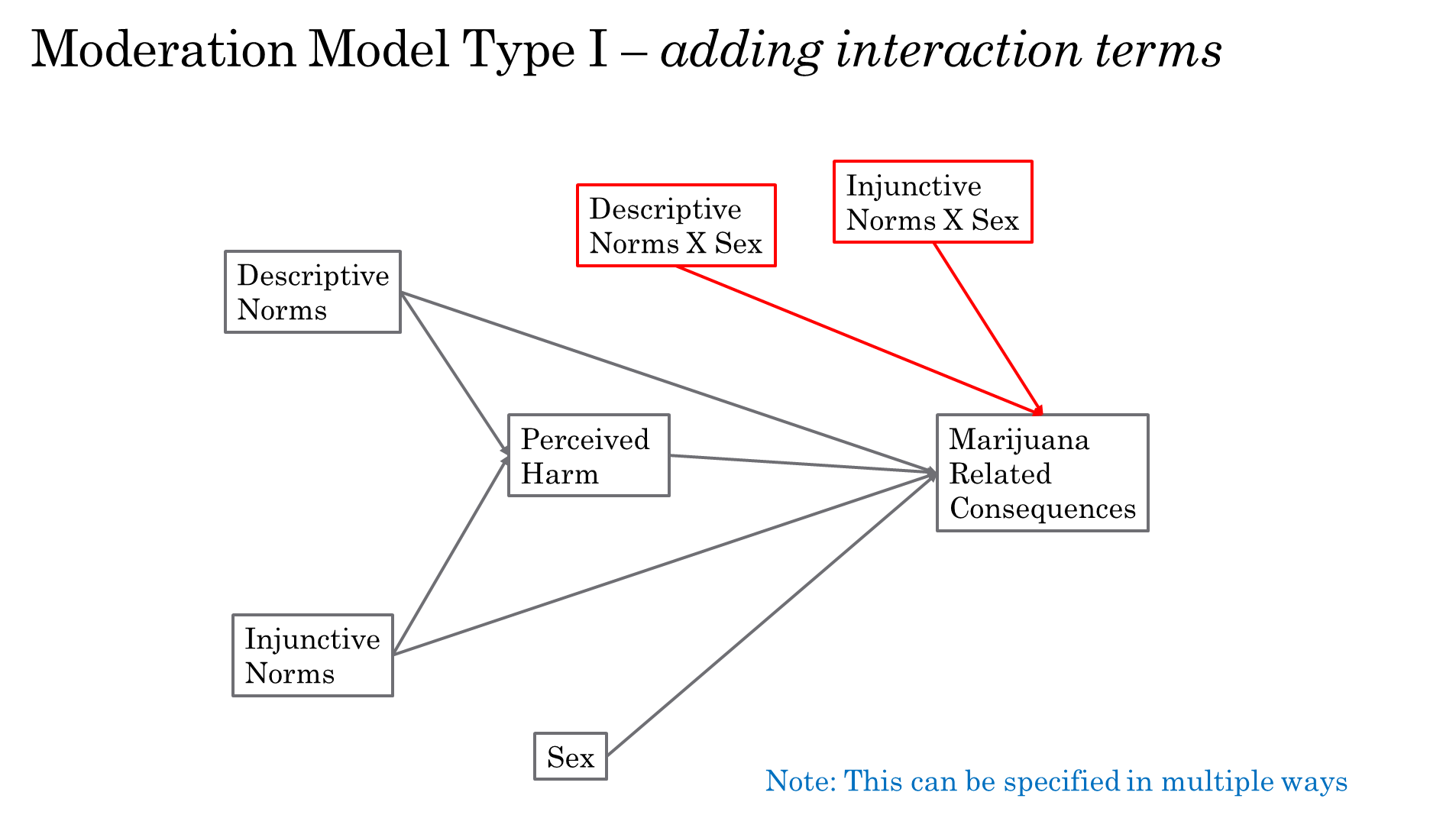

Red lines (interaction terms) are actually moderating the 2c paths and the b of predictors

But this is a cleaner way of writing it when you are preparing for code